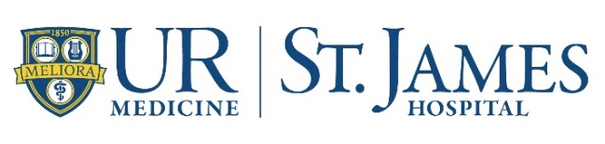

2022 St. James Foundation “Stomp Out Breast Cancer” Sponsor Form

Company or Individual Name: _____________________________________________________________

Contact Name: __________________________________________________________________

Mailing Address:

____________________________________________________________________

____________________________________________________________________

Email Address: ______________________________________________________

Phone Number (Office and/or Cell):

Office: (______)______________________________

Cell: (______)______________________________

Sponsorship Dollar Amount: __________________________________________

Please make checks payable to “St. James Foundation”

In-Kind Gifts: If you would like to donate prizes, gifts or services, call Carmen Wilkins at
607-247-2250, or mail it to the address listed below.

For financial or in-kind sponsorships and donations, please respond by 10/20/22.

Please mail checks, along with this completed form, in the enclosed envelope, to:
St. James Hospital
c/o Carmen Wilkins
7329 Seneca Road North
Hornell NY 14843

To make a credit card donation or if you have questions, please contact Carmen Wilkins at
Carmen_Wilkins@URMC.Rochester.edu; 607-247-2250.

